Caprock Pest Management Newsletter Dagan Teague
Floyd and Crosby Counties Date: Aug.21,2020
Cotton
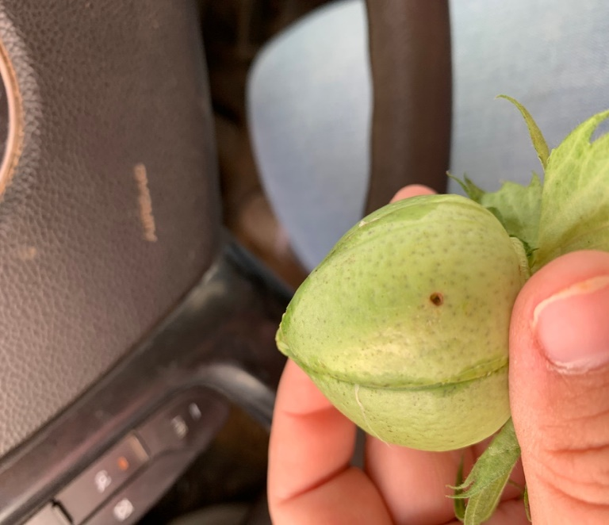
This week in cotton we were finding small bollworms in some non-Bt cotton fields that were above threshold (6% damage or 8,000 worms per acre). For the next few weeks scouting will be crucial, for the numbers may increase. Moth traps can be a good way to monitor populations but cannot tell us an accurate count.
Boll worm damage penetrating carpel wall of a fully developed boll
Here I cut open the boll and you can see the bollworm and where the feeding was taking place on the lint.
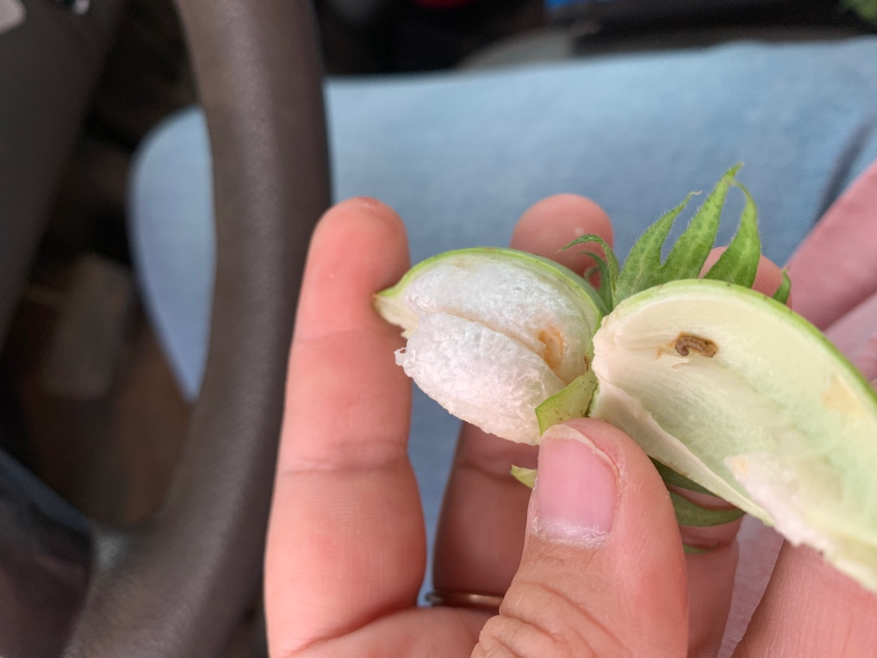
Bollworm larvae full-grown are about 1 1⁄2 inches long and vary in color from pale green, pink, or brownish to black, with stripes along the back.
They are attracted to and lay eggs in cotton with lush new growth. Moths sometimes deposit eggs on squares, bolls, stems, and lower parts of the plant. Plants are most susceptible when cotton plants are stressed, periods of high temperature, or low humidity.
Moths usually lay single eggs on the tops or undersides of young, tender, leaves on the tops of the plant. However, in Bt cotton, moths frequently lay eggs on blooms, bloom tags, or other tissues deeper in the canopy because these tissues have lower concentrations of Bt protein toxins.
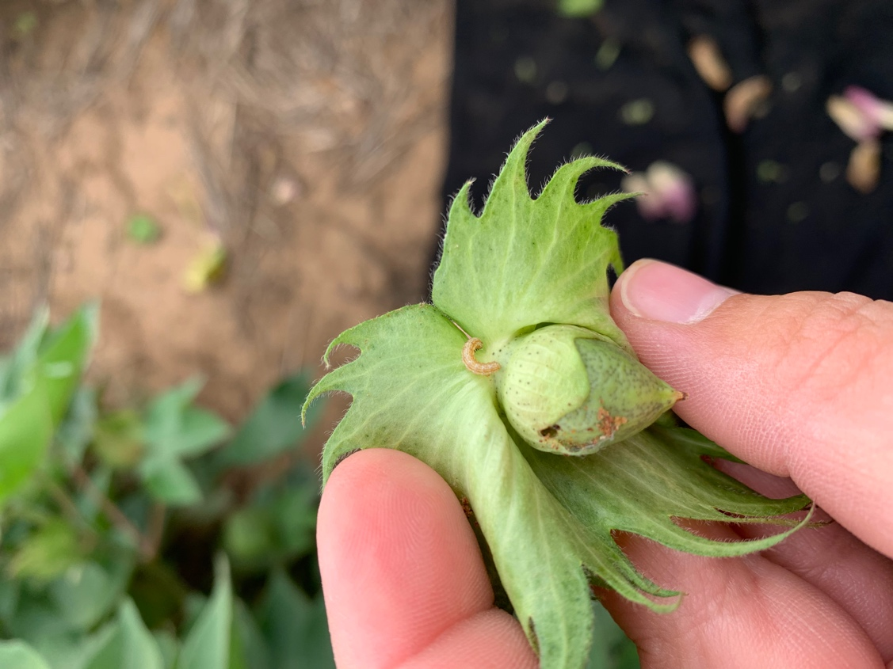
Eggs are white to cream color and about the size of a pinhead or smaller. Eggs hatch in 3 to 4 days, turning light brown before hatching. Young worms usually feed for a day or two on leaves, leaf buds, and small squares in the plant terminal. They then move down the plant to attack larger squares and bolls.

Small worms are most vulnerable to insecticides when they are in the upper third of the plant. Therefore, it is so important to have a good scouting system supporting cotton this time of year.

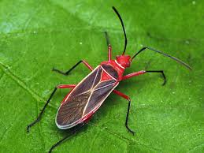
There also has been a few cotton stainers seen around as well, but nothing over threshold to be worried about spraying for.
The cotton stainer is a true bug that has piercing-sucking mouthparts. This damages developing bolls by puncturing seeds and causing plant sap to stain the lint.
Cotton stainer
Along with stink bugs this pest is more about quality purposes at the gin. This is different from the loss of fruiting bolls seen associated with lygus or cotton flea hopper. It doesn’t take much to drive quality down to undesirable levels.
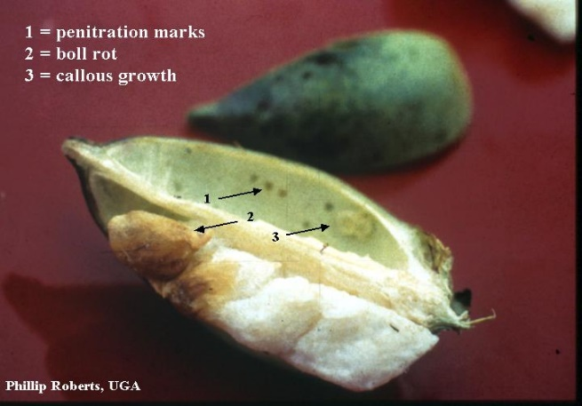
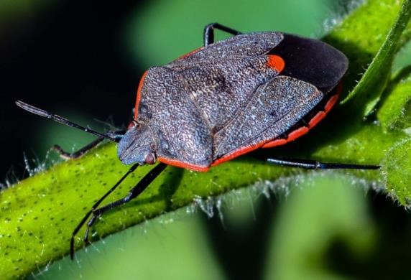
There have been a few stink bugs, as well as eggs, found in some fields. Stink bugs have piercing sucking mouthparts and damage cotton by piercing the bolls and feeding on the developing seeds. Stink bug infestations can cause substantial economic losses through reduced yield, loss of fiber quality, and increased control costs. Feeding on young bolls will usually cause the boll to be shed. Larger bolls with feeding damage will appear to have dark spots. The 2 pictures are of the common stink bugs found here.
Green Stink bug
Conchuela Stink bug
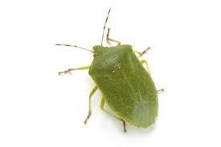
Scouting for stink bugs remove about 100 bolls about the size of a quarter from different parts of the field, avoiding field edges. Check bolls with visible external lesions, dark spots, break open the bolls by hand or cut them with a knife. Then look for internal warts on the boll walls and stained lint on the cotton locks. determine if the internal damage threshold based on boll sampling, treat cotton with an insecticide when stink bugs are present and 20 percent or more of the quarter-size bolls have internal warts or stained lint.
There has also still been calls about Verticillium wilt in the Floyd county area. Again, very little you can do now, but there are off-season measures you can take for the next growing season. Some other practices to try are to use tolerant varieties, and crop rotations.

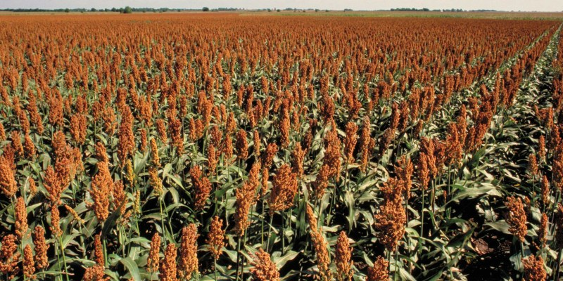
Lastly, as cotton progresses through this growing season remember that natural shed is going to occur. As the plant reaches maturity it allocates resources based on need. If under stress during cutout it will throw bolls as necessary to preserve larger boll’s health and stability. Resources will then go into those larger bolls vs to the smaller bolls that may or may not have made it. This is always a case by case basis.
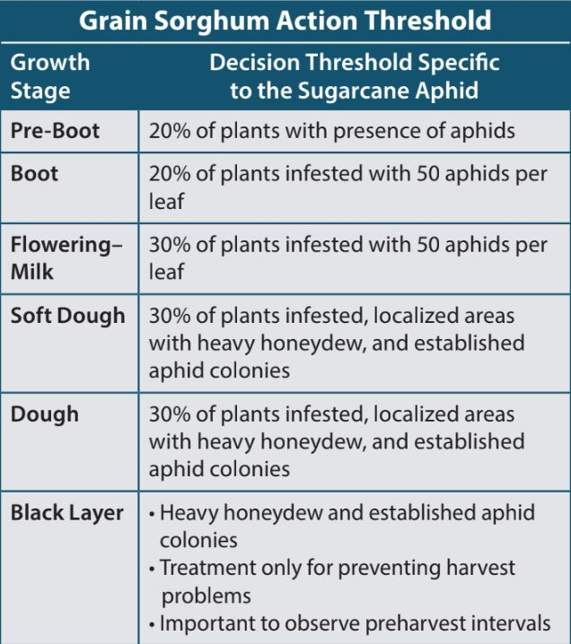
Sorghum
Just about all of the irrigated acres of sorghum in the area have been sprayed for aphids. We are also seeing some whirl feeding happening, but little damage is happening this late in the game.
Sorghum headworms have been found in a few fields. AgriLife Extension has a page to calculate for sorghum headworm. The threshold for headworms are 1 half grown worm per head. Also, need to keep an eye out for Midge during grain fill as well as the headworms. https://docs.google.com/spreadsheets/d/1m9CJqnmvYZ-2uF7bzcBmQKMinKsgaQlrbuLWMPCLJ8Q/htmlview

 | 2020 Adult Bollworm Moth Traps
Counties | 3rd  week of  July | 4th  week  of July | 5th  Week of July | 1st week of Aug. | 2nd week of Aug. | 3rd  week of Aug.
Floyd | 5 | 5 | 84 | 45 | 25 | 36
Crosby | 5 | 5 | 45 | 32 | 22 | 23
Hale | 21 | 23 | 14 | 28 | 2 | 0
Swisher | 3 | 12 | 44 | 215 | 5 | 46
Castro | 109 | 40 | 72 | 49 | 16 | 18
Parmer | 32 | 26 | 31 | 28 | 12 | NA

Thank you to our 2020 Newsletter Sponsors for making this year possible!

Owens Gin
Happy State Bank

Dagan Teague IPM Agent
(361) 494- 7075
Dagan.teague@agnet.tamu.edu
Floyd County AgriLife Extension
122 E California Street, 79235

