Caprock Pest Management Newsletter Dagan Teague
Floyd and Crosby Counties Date: Aug.28,2020
Cotton
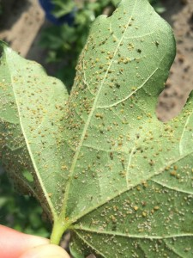
This week in cotton in terms of insect pressure it has been fairly quiet in both counties. While this is nothing to mosey over scouting is still crucial coming into the end of August. Cotton is bolled at the tops of the plants already making the plants safer from most pests except cotton aphids. While they have not made a big entrance they have been seen in some fields.
Cotton Aphids
Aphids extract phloem sap and its sugars from the plant, robbing it of energy otherwise used for growth or fruit production. Heavy and prolonged infestations can cause leaves to curl downward, older leaves to turn yellow and shed, squares and small bolls to drop off, and smaller bolls to develop, resulting in incomplete fiber development. A small number of aphids in a cotton field can be a good thing. Aphids are the favored prey of many insect predators, and attracting these predators into a field could help manage other pests such as bollworms and budworms.
The food source aphids feed on is rich in sugar, to rid themselves of excess sugar, they excrete copious amounts of sugars, forming a sticky-sugary substance called honeydew. With heavy aphid populations, honeydew collects on the leaves, giving them a shiny, sticky appearance. A black, sooty mold grows on the honeydew, covering the leaf and inhibiting photosynthesis.

Late in the growing season and once open bolls are in the field, honeydew can accumulate on the lint of the open bolls. Even under low infestation levels, cotton aphids can excrete enough honeydew to contaminate the lint, causing “sticky cotton” that causes loss of fiber quality and costly problems. This also inhibits smooth harvest, as it could, in extreme cases, gum up cotton strippers.
Sorghum
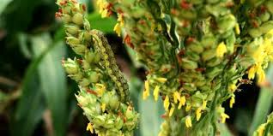
Going into grain sorghum there have been a few fields sprayed for corn earworm and fall armyworm larvae (headworms). They feed on the flowers and on the developing grain hollowing out the kernels. The last two larval stages cause about 80 percent of the damage. Frass and fragments of grain kernels accumulate on top of the upper leaves and on the ground under plants where the larvae are feeding. Many small corn earworm and fall armyworm larvae typically parish because of predators, parasites, pathogens, and cannibalism. Infestations are less common in early-planted sorghum and in sorghum hybrids with loose (open) grain heads.
Sorghum Headworm

AgriLife Extension Head worm Calculator
https://docs.google.com/spreadsheets/d/1m9CJqnmvYZ-2uF7bzcBmQKMinKsgaQlrbuLWMPCLJ8Q/htmlview

Another pest to be mindful of is sorghum midge. Begin scouting for sorghum midge soon after head emergence, when yellow blooms first appear. The adult lives for 1 day, and each day a new brood of adults emerges. For this reason, you need to sample flowering fields almost daily.
One sampling method is to use a milk jug with the bottom cut out, slip it over the head of the plant, then rapidly shake into the jug. Tapping the head to the sides of the jug disturbs the midge. The midge will then fly out of the head into the jug, where you can easily see and count them, and input them to this calculator located below.

AgriLife Extension Sorghum Midge Calculator
http://entomology.tamu.edu/extension/apps/
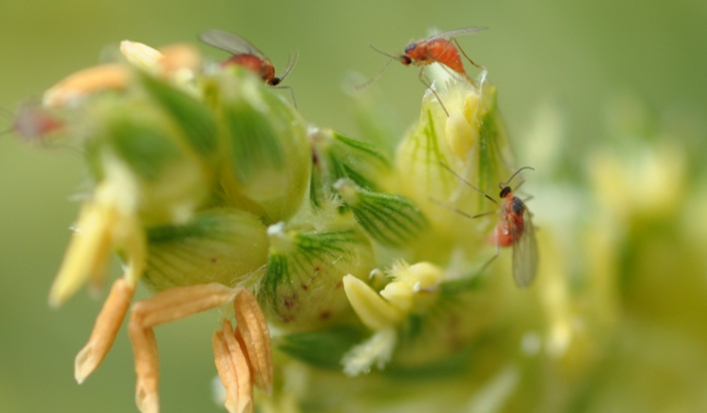
Sorghum Midge

 | 2020 Adult Bollworm Moth Traps
Counties | 3rd  week of  July | 4th  week  of July | 5th  Week of July | 1st week of Aug. | 2nd week of Aug. | 3rd week of Aug. | 4th  Week of Aug.
Floyd | 5 | 5 | 84 | 45 | 25 | 36 | 22
Crosby | 5 | 5 | 45 | 32 | 22 | 23 | 18
Hale | 21 | 23 | 14 | 215 | 20 | 0 | 29
Swisher | 3 | 12 | 44 | 28 | 20 | 26 | 15
Castro | 109 | 40 | 72 | 49 | 16 | 18 | 20
Parmer | 32 | 26 | 31 | 28 | 12 | NA | 8

Thank you to our 2020 Newsletter Sponsors for making this year possible!

Owens Gin
Happy State Bank

Dagan Teague IPM Agent
(361) 494- 7075
Dagan.teague@agnet.tamu.edu
Floyd County AgriLife Extension
122 E California Street, 79235

